A Brief Report
One-Day Workshop on Discipline Specific Curriculum Construction for Professional Development Program
(September 26, 2019)
Organized By:
Teaching Learning Centre
Tezpur University

Teaching Learning Centre, Tezpur University organized a one day workshop on discipline specific curriculum construction for professional development program on 26 September, 2019. Curriculum Development is one of the essential parts of education. Teachers are often engaged in curriculum development for students. However teachers also need to incorporate the changes in their field for the continuous professional development. While discipline specific development should be incorporated, we can’t also ignore the tools and techniques as well and latest technology introduced in the different disciplines. A general or universal training may not be fruitful in this regards. Therefore, we need discipline specific training program. Hence, TLC has drawn a 3-Stage plan

Stage 1: A One-Day workshop is conducted on Curriculum Construction for discipline specific Professional Development Program(PDP). An eminent expert will deliver on the nuances of curriculum development followed by discussion with the participants. The participants will be nominated/deputed by HODs to represent their particular departments. After the training, the participants will be able to develop curriculum for PDP. This one day workshop falls under Stage-1.

Stage 2: In this stage the participants will consult the faculty members from their respective departments to construct a curriculum for PDP. If necessary faculty members from other institution may also be consulted. A semi-formal meeting-cum workshop can be organized by the interested departments at TLC premises. The department will finalize the curriculum and submit it to TLC for implementation

Stage 3: The submitted curricula will be implemented in the form of weeklong professional development programs for the benefit of the specific departments. Faculty members of the similar/allied discipline from other institutions will also be invited for the training. Depending on the feedback of the participants, the curricula will be updated and finalized.
TLC plans to organize the weeklong professional development programs in a phase wise manner. Up to 4 workshops will be conducted per financial quarters in collaboration with concerned departments of Tezpur University. All such programs will be fully supported and funded by TLC,TU under PMMMNMTT Scheme of MHRD, GOI.

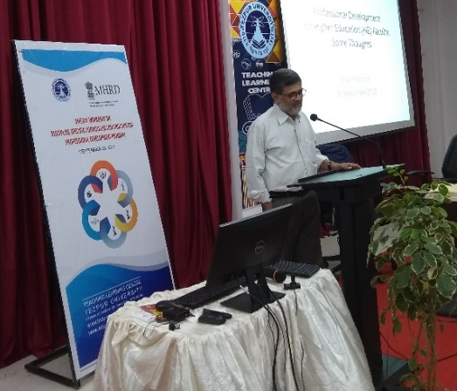
Stage-1 has been completed on 26/9/19. Professor Shyam B. Menon, curriculum expert, Professor in the Central Institute of Education, Delhi University and former Vice-chancellor of Ambedkar University was invited as the resource person of the day long workshop. Twenty-six faculty members from 15 departments/centers were nominated by their respective HoDs to participate in the workshop. Professor Shyam Menon delivered throughout the day on different aspects of curriculum development and professional development programs. There were altogether four sessions. There were discussions and interactions with participants in every session.

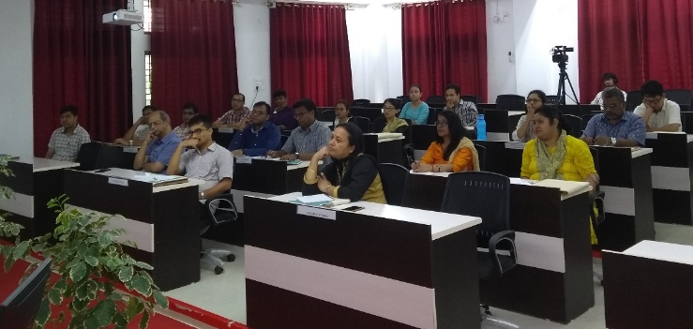
The resource person started with a note on professional development in higher education and then delivered briefly on the development of higher education sector in India. Later on the resource on discussed the following points on curriculum development: Curriculum as an Assemblage of Purposively Chosen Elements that constitute a Comprehensive Learning Environment, Curriculum as an Assemblage of Elements Purposively Chosen, difference between Explicit Curriculum and Hidden Curriculum. He emphasized that a. Curriculum should focus on What Is and What Should be retained and assimilated b. Every element of the curriculum should justify its purpose for contributing to the realization of the larger curricular goals c. Curriculum Development is an Exercise of Rejection than Selection of Elements.
Photo 1 Professor Shyam Menon

Regarding discipline specific curriculum, the speaker noted that it should include a. Emerging Frontiers, b. New Approaches, Tools, c. Methods of Research d. Specific Issues related to curriculum development e. Learning of the Discipline f. Pedagogic Possibilities and g. New Approaches to Assessment and Evaluation.
Photo: 2 some of the participants
The resource was taking feedback from participants in a regular basis. The participants were able to learn different aspects professional development, curriculum development and discipline specific curriculum development. There were extensive discussions with the participants

The workshop was concluded with a brief valedictory ceremony presided over by Prof. P. K. Das, Chairperson, TLC Advisory Committee and Director-in-Charge, TLC. Oral feedback was taken from participants. The program ended with singing of national anthem.

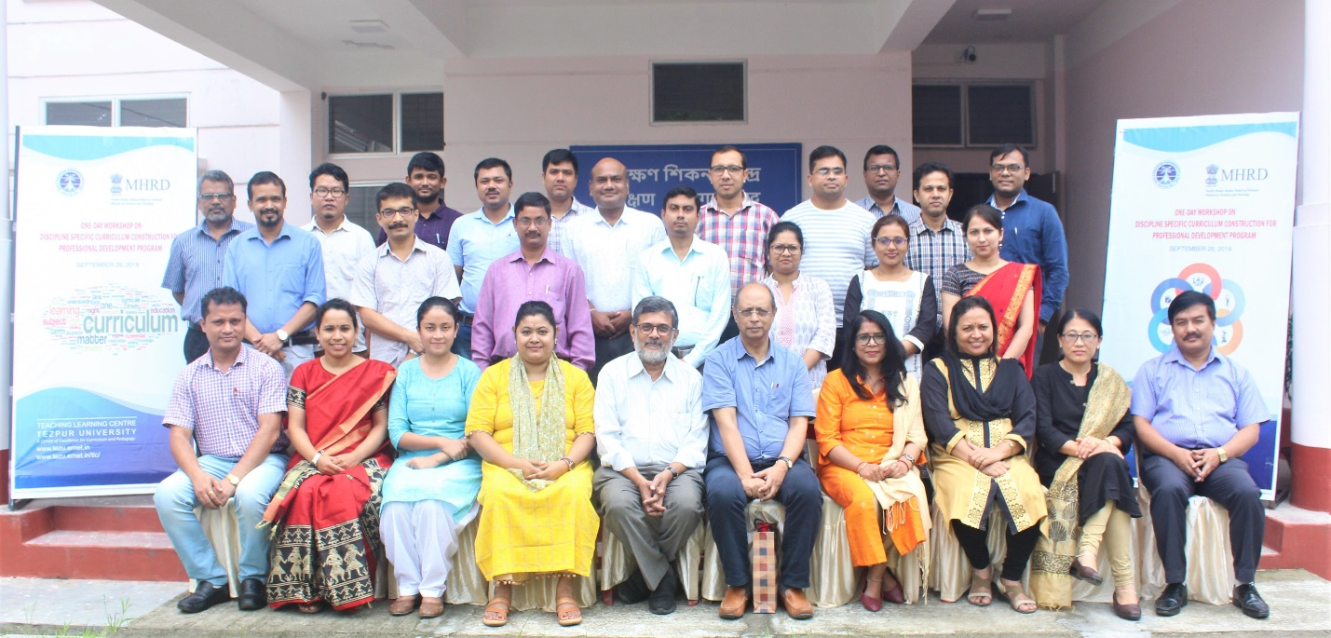
Participants along with Prof. Shyam Menon, Prof. P.K. Das and TLC faculty, and staff.

